After the PDP session on Growth Mindset, review the 3 strategies and choose one to implement this week. You could share what you’re going to implement in our WLA LinkedIn group for support and accountability.

Strategy #1: Reframing

Step 1: Tune into your fixed mindset voice during the next few days. It might sound like this:

- I’m rubbish at presenting
- What if I fail?
- I’m scared to try

Make a note of what comes up for you.

Step 2: When you have your list of fixed mindset phrases, think about how you could reframe them with a more growth mindset approach.

Fixed Mindset Voice | Reframe
I’m rubbish at presenting | I don’t present as well as I’d like yet but I know I can improve
What if I fail? | Successful people fail all the time
I’m scared to try | If I don’t challenge myself, how will I grow?

Step 3: When you hear your more fixed mindset voice in the moment:

- Notice it
- Talk back to it with the reframe
- Take the growth mindset action!

When you’ve worked through Steps 1 and 2, Step 3 starts to become much easier.

Strategy # 2: Judger vs Learner

We can be super hard on ourselves, especially when things go wrong. Try to build increased awareness of when you judge yourself or blame yourself (and others) for things. When you judge, this is a fixed mindset approach and it’s easy to get stuck.

The strategy to overcome this is:

A: Awareness
Really tune into what you’re saying to yourself and others and feeling.
B: Breathe
Take a few deep breaths to ground yourself
C: Get curious
Ask yourself questions (see the Choice Map in the replay and/or slides). The brain can’t hold judgement and curiosity at the same time so getting curious really is the antidote. When I feel myself going down the judgement path I say to myself ‘How fascinating! I wonder…?’ Even if you don’t really feel fascinated, it’s all your brain needs to switch into learner mode.
D: Decide
Think about and take action on a learner/growth mindset path

Strategy #3: Relearning Goals

Performance goals can leave us overly fixated on the end results, triggering our fixed mindsets and leaving us overly worried and anxious about how we’ll be evaluated by ourselves and others. On the other hand, setting specific and challenging learning goals helps us to focus on the strategies, skills and knowledge we need to develop and what we’ll learn in the process, so they’ve been found to help us perform better.

We’re more likely to achieve our goals when we have multiple pathways towards making them a reality . For this reason, I encourage you to set not just one learning goal, but several - think of them as small experiments you’re running - to try to help you achieve the performance outcome you want.

For example:
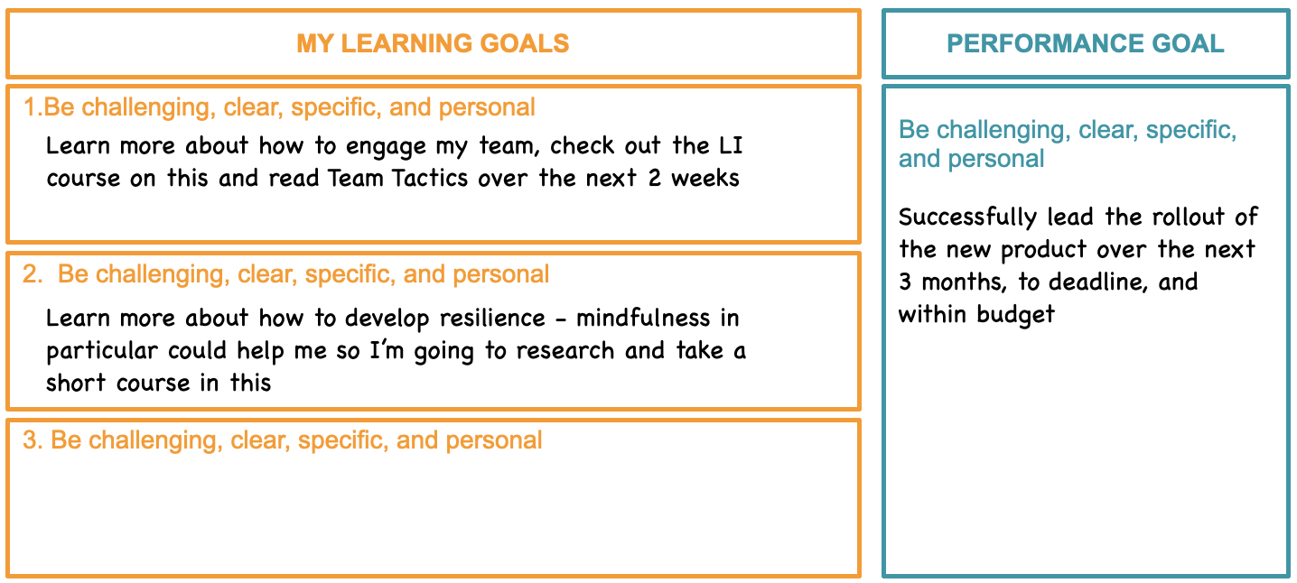

The more challenging goals you set for yourself, you’re going to have more opportunities for failure. Most of us learn at an early age that failure feels bad so we do our best to avoid it. The more we can rewire our brains to trigger learning and growth through normalising failure (or even welcoming it!) the better.

Carol Dweck suggests that at the end of the day you should ask yourself: “What did I struggle with today?” and if your answer is nothing, then we have more to reach for tomorrow, because if we’re not struggling even a little bit, we’re not learning or realising our potential.

Tracking how you’re going in relation to your goals is helpful because you create a feedback loop to review your efforts, celebrate success and think about what’s working and where you’re still struggling.

You might like to check in at the end of each week with these questions:

